**SOAD-S 210 Digital Art: Survey + Practice** FA 215

Instructor:

Office hours:

Email:

Doyle Partners, *Hypertext Sculpture*

**Project 2: Hypertext**

In this project you will create a Hypertext Interactive Storytelling on the Internet with a careful attention to detail so that users will discover a rich world and/or narrative as they navigate through your space. It must convey a deep and critical experience through observation of details in an Internet space. Think about how you already interact with the Internet in your daily life. In what ways can you subvert or complicate this online routine? Think about what makes discovering information on the Internet a unique experience and how your 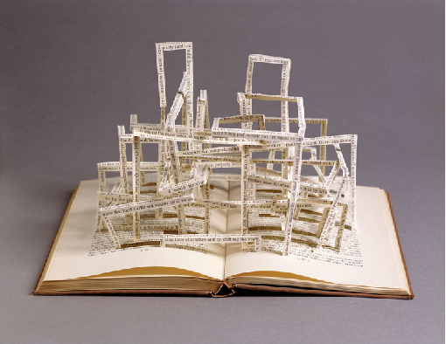Internet scene is part of a physical, historical, or narrative interaction with web space.

The content can be whatever you wish, but it must draw attention to the idea that discovering visual, audio, or hyperlink clues on your webpage helps to uncover new meaning in the artwork. How can the action of clicking, stumbling across unexpected moments, or linking to new places change the artwork’s content? Or, would you prefer for your viewer to have a directed experience, in which they only have one choice (or the semblance of one choice?) How does that affect the content? Creating a narrative is acceptable, but use the narrative as a vehicle for a deeper critical message that addresses web interactivity directly.

You will begin by sketching a detailed and organized Decision Tree (or Site Map) as your proposal. If you draw it by hand, you may take a picture of it with your phone and upload it to the Box as a .jpg. Then you will build your scene through a web “space” with multiple pages in Dreamweaver that, for your critique, will be experienced live on the Internet by a classmate. Content, images, and backgrounds for your site can be created in Photoshop.

Within your scene you must build 10 “interactions”. You must have at least 3 different types of interactions (consult the *Types of Interactivity* guide on Canvas >Files). Interactions can be defined in a variety of ways: a button with a hyperlink to another website, a mouse click which activates a television turning on, a press of a key that moves us to another view of the space we are in or a whole new space, a rollover image that changes color, an action that cues a song or sound effect, etc. We will use Dreamweaver to create the HTML and CSS for our web space. If you know other coding languages you are welcome to use them!

There are many ways to use the internet, but for this assignment we are creating an artwork. Do not make an informative site whose main object is to clearly convey information or serve a purely informational purpose. If you create a game, be sure that it has critical and unexpected objectives instead of focusing on entertainment and pleasure.

We will use IU’s Pages and Cyberduck to host our finished websites. You will want to test your website “live” before turning your project in. Files that were mismanaged on the front end could go offline once a site is live. **Leave yourself plenty of time to test your website before your class critique!** Learning how to use the web and empowering your ability to navigate technology is very important. Please note: Your Cyberduck and Pages Account takes 24 hours to activate. Be sure to activate them far in advance of the project’s due date.

**Successful Projects Will:**

* Consider what makes the Internet unique and how a user’s interaction with your website can create new meaning
* Consider interactivity, how interactions *feel* to the user, and how to make the interactions inseparable from the content

- A careful attention to the images and sounds that create the scene

- A consistent aesthetic tone

- A scene that provides a critical experience for the viewer’s interaction

- A scene that creates a narrative, space, or history through details

**TURN IN:** **(1)** your Proposal and Decision Tree / Site Map DUE 10/8 before class

a folder containing **(2)** your .html and .css files along with all assets (images, audio files, etc.) **(3)** a WORKING link to the published online site through IU’s Pages

**(4)** a sub-folder containing research content, sketches, and any beginning iterations of the project that you would like to share to illustrate your creative process. Name the final folder upload in the following format: **LastnameFirstname_Project2** DUE 10/16 before class

**(5)** After your group critique, you will submit a one-page Self Evaluation describing your approach to the project and your decision-making process (the who, what, and why)

DUE 10/21 by midnight